Table 1
The Number of Moebius Strip Produced by Group _________
表一：第______組「莫比帶」產量表

No. of Labor  勞工數目 | Toothpick牙籤 = 1:  K = 1  A = 1 | Toothpicks牙籤 = 2:  K = 2  A = 1 | Glue Pen膠水筆 = 1:  K = 1  A = 2
0
1
2
3
4
5
6
7
8
9
10
11
12
13
14
15
16
17
18
19
20

Table 2.
The Class Average of Moebius Strip Produced
表二：「莫比帶」平均產量表

No. of Labor  勞工數目 | Toothpick牙籤 = 1:  K = 1; A = 1 |  |  | Toothpicks牙籤 = 2:  K = 2; A = 1 |  |  | Glue Pen膠水筆 = 1:  K = 1; A = 2
No. of Labor  勞工數目 | TP_{L} | MP_{L} = TP_{L}/L | AP_{L}  TP_{L}/L | TP_{L} | MP_{L} = TP_{L}/L | AP_{L}  TP_{L}/L | TP_{L} | MP_{L} = TP_{L}/L | AP_{L}  TP_{L}/L
0
1
2
3
4
5
6
7
8
9
10
11
12
13
14
15
16
17
18
19
20

Fig. 1 How to Produce A Moebius Strip

- Start with a long rectangle (ABCD) made of paper. 取一條紙條

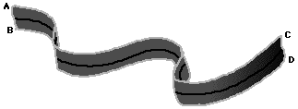

- Give the rectangle a half twist. 將紙條的一邊扭轉180度

- Join the ends so that A is matched with D and B is matched with C. 黏貼在另一邊上。

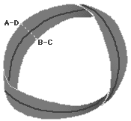
Figure 2: Classroom Setting
圖2：課室位置安排

Blackboard
seat |  | seat |  | seat |  | seat
seat |  | seat |  | seat |  | seat

